Individual Teacher Technology Assessment Narrative
Brandy Beavers
Kennesaw State University

Mrs. Barber is a third grade teacher new to her grade level. She has previously taught at North LaFayette Elementary for one semester last year as our school Literacy Lab teacher. Although she did work one semester, Mrs. Barber feels very new to our school, the technology applications that we use, and her grade level. She graduated from college in December of 2017. She was given the technology questionnaire that my PLC group completed. The goal of these questionnaires was to gauge her comfort level with technology, how she uses it in her classroom, and her current perspective about technology in general. She is currently teaching reading and writing to half of the third grade (our teachers team teach in third grade). Her third grade classroom is equipped with a SmartBoard, one student desktop, a class set of Chromebooks, and one teacher issued laptop. Furthermore, students are also allowed to use technology in their Literacy Lab block, as well as in our media center. The school does provide other resources for teachers to be able to check out, such as the new Osmo devices, document cameras, etc.
Levels of Technology Use and Change
During our meeting, following the completion of the questionnaires (part 1 and 2), Mrs. Barber was able to confide in me about a lot of difficulties that she is having this year. She does not feel comfortable with the implementation of technology, but she is trying it as much as she can. She did begin her career as the Literacy Lab, however, she said that her lesson plans were all pretty much already completed, so she just did the things that the other teacher had planned for the students. She did not “branch out” to discover her own methods of teaching with technology. Therefore, this year has been quite difficult for her with all of the planning and technology integration that goes into a third grade classroom. Mrs. Barber stated, “I love to learn. I am open to any new technology secrets that I can get my hands on. I would love to attend trainings, but just not sure which trainings would be best for me specifically” (B.Beavers, personal communication, October, 2018). Mrs. Barber stated that she tries to use technology as much as possible, but finds that she mostly uses the chromebooks in her small group stations, and for a free time reward to use with games. The technology is currently not being implemented into every lesson, but she knows that building the technology into her lessons will only help her students become more independent, and help that independence continue until the end of the school year when they will be expected to take their GMAS assessment on these chromebooks. Mrs. Barber is familiar with our basic programs at North LaFayette Elementary, however, she has not been properly trained, and does not understand how to get the information that she wants off of these programs. She understands that although these are fun games for students, these programs offer a great deal of supports and interventions for weak areas that her students may have. In addition to learning how to properly use these programs and the data that they provide, Barber would love to see her students use technology to begin to create extended writing activities, and complete research and more project-based learning activities.
Based on discussion of technology knowledge and usage, I would say that Mrs. Barber’s practices are currently falling within the LoTi Level 1 category of Awareness. At this level, she is the solitary user of technology in her classroom. Her enthusiasm for wanting to learn and implement mean that she would be not far away from the exploration and infusion levels of the LoTi.
Mrs. Barber also included that after she is shown things one time, she can use them and normally finds quicker ways of doing things and shows her peers. She wants to be a leader once she understands more basic knowledge of the programs that we use. She stated that she does not become upset when new innovations and ideas are introduced, and she will try to use these new things in her classroom. However, she will also be aware of how these new things are working with her students specifically, and if they are not good for her students, then she will not use them in her classroom. Mrs. Barber would potentially identify as either an Early Adopter of Early Majority. I believe this because she uses the data to decide whether or not something is working for her students. She uses this information to decide whether or not she will implement these programs into her instruction.
Technology Perspective
Although Mrs. Barber believes that technology will have a huge impact on the future of education, she also believes that she lacks the training and comfort to be able to implement a lot of technology applications into her instruction. She believes that with proper training on the programs that North LaFayette has adopted, she would be better equipped to choose which programs would be best for her students’ success.
Also during our discussion, Mrs. Barber stated that her students are currently using technology a lot for fluency practice, skills review, and basic skills, like Accelerated Reader tests. She is beginning to implement all of their writing activities on Google Docs and Google Classroom. However, her students are still learning the basics about writing a solid paragraph. She would like to be able to “build on these basic writing skills, and lead into more in depth skills such as researching, brainstorming ideas for graphic organizers and using those for writing, and more project-based learning activities” (B. Beavers, personal communication, October, 2018).
Technology Training Needs and Coaching
When asked about what her greatest needs for coaching were, Mrs. Barber stated that she would like to learn more about the programs that North LaFayette Elementary uses for student learning. These programs include: IXL, Study Island, Read Theory, and Reading Wonders, which directly correlates to the reading resources that teachers use in grades K-5. This need will be focused on in my upcoming webinar training sessions that are part of my Capstone Project. Mrs. Barber has agreed to also meet with me to work through these webinars so that she can ask questions, and offer feedback to me so that I can appropriately plan for future webinar trainings. She also has suggested that I offer an optional after-school training where we can work collaboratively as teachers and offer support to one another with these programs. I will be using the partnership and peer coaching approach in order to allow us to work alongside one another. I will be training her, as well as other teachers, in hopes that we can all work together in order to make this technology integration more successful and purposeful. Based on our discussion and Mrs. Barber’s eagerness to learn, I know that she will do a great job of sharing her knowledge and training others once she is given the support and coaching that she needs.
We will begin by giving a pre-survey as to the level of knowledge about the programs that we are focusing on. We will focus on the three programs that she is not currently using in her instruction, and these are Study Island, IXL, and Read Theory. She has identified these three as being the most important, because she feels that she is working her way through the Reading Wonders Program, and that she may not need as much training for that specific program. From there, we will look at the data from the survey to see which areas of the program that we need to focus on. After each session with Mrs. Barber, I will continue to gather feedback about each program and the progress that we are making. We may find other areas that need work as well as we move through the trainings. I will keep in mind that she is letting me train her because she wants to learn, so I will guide my trainings based on her feedback and suggestions that she wants from me. We will discuss lesson plan options, and how to integrate these programs into her instructional practices. Mrs. Barber will be asked to demonstrate her knowledge by using the peer coaching approach to assist another colleague who may be having similar difficulties.

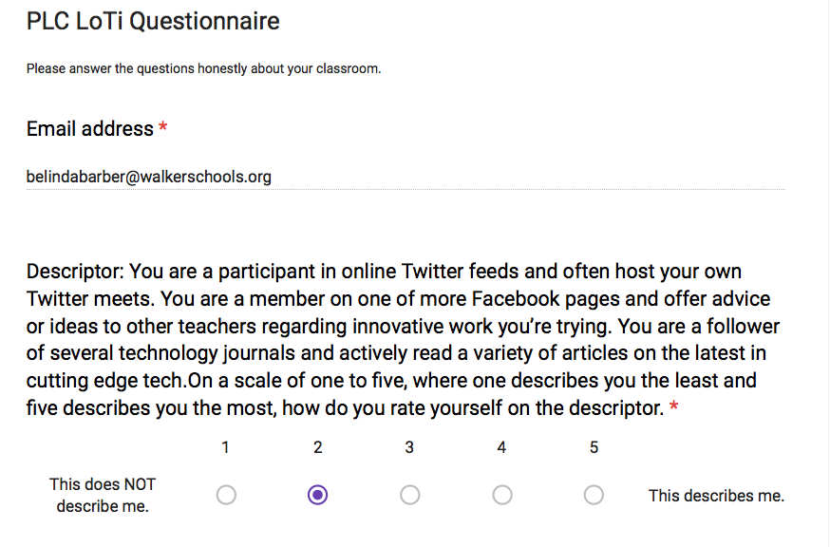
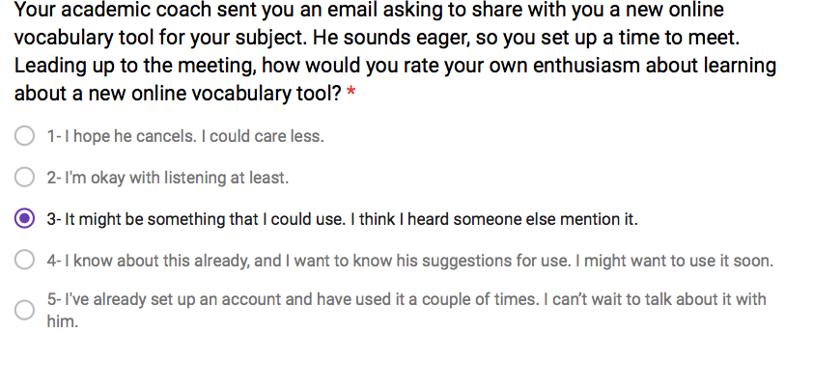
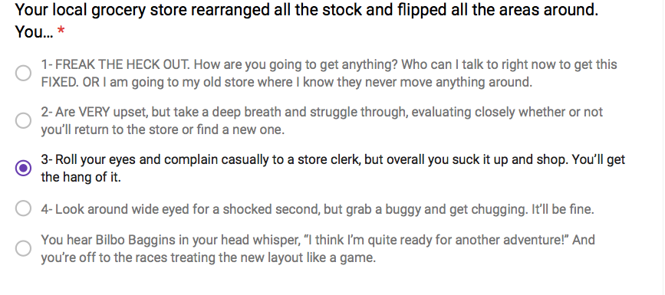
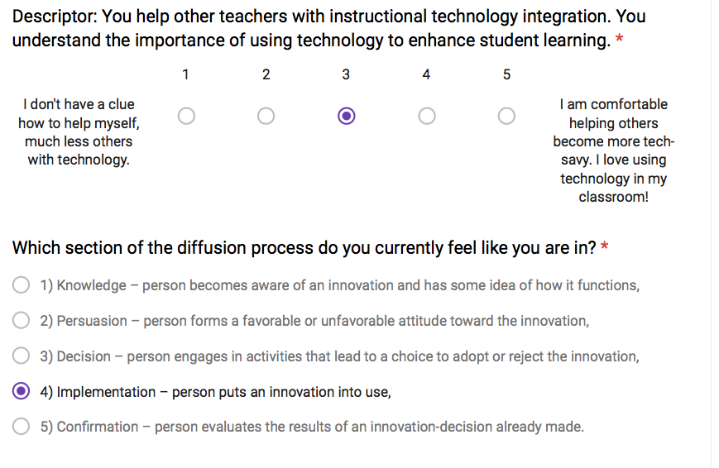
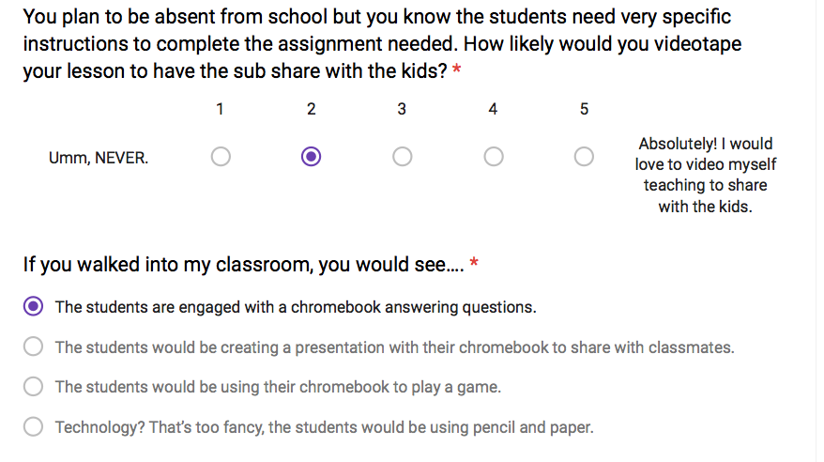
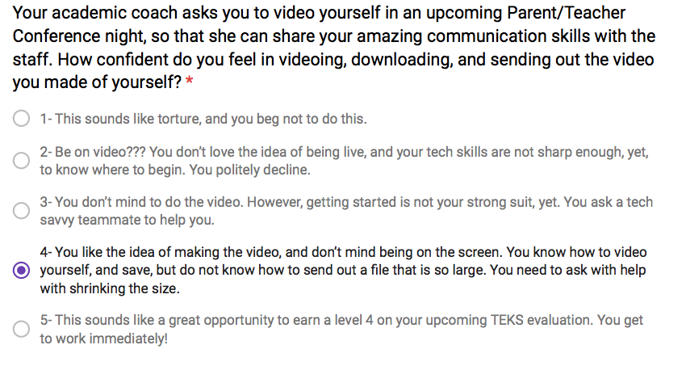
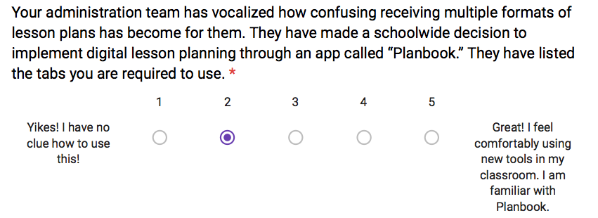
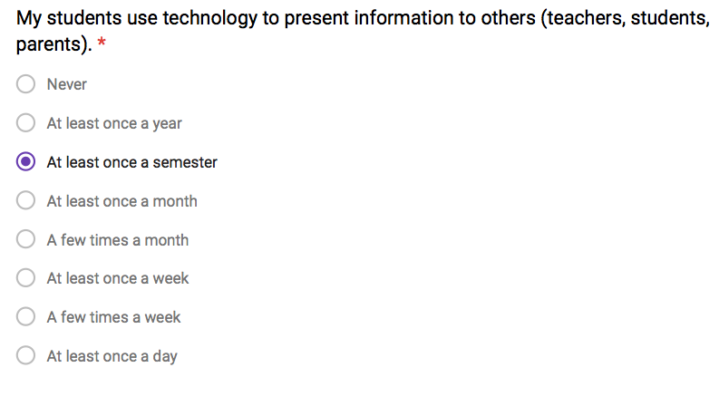
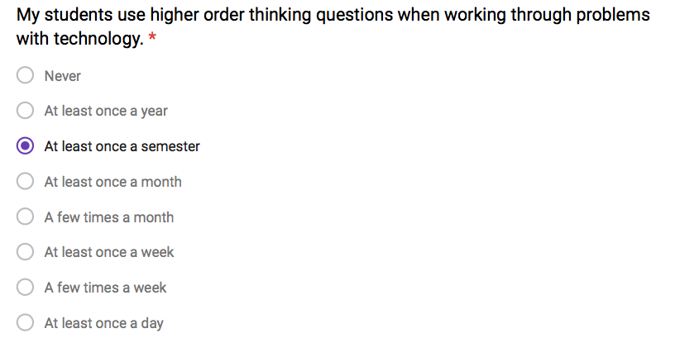
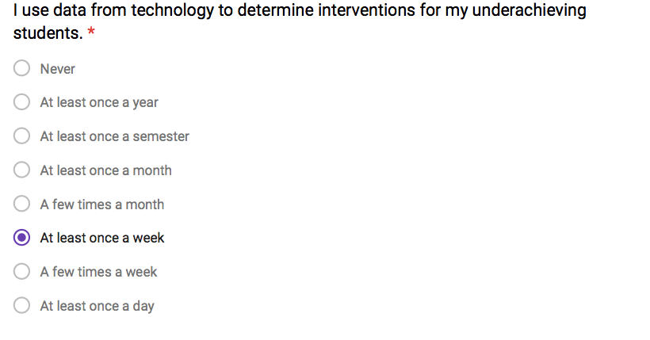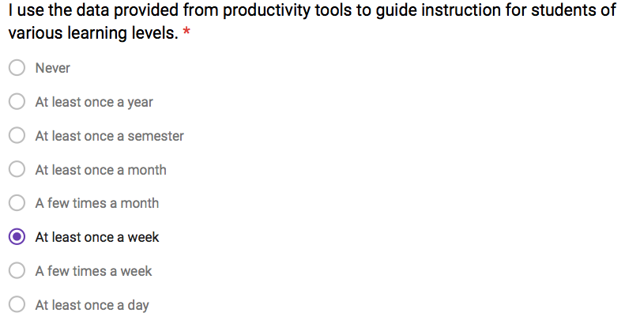
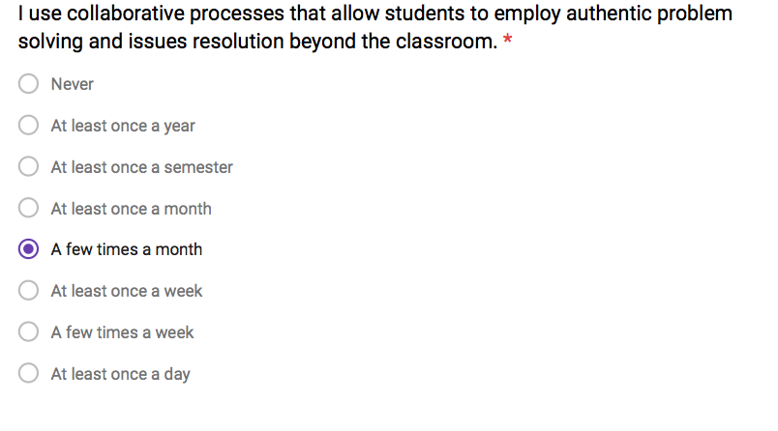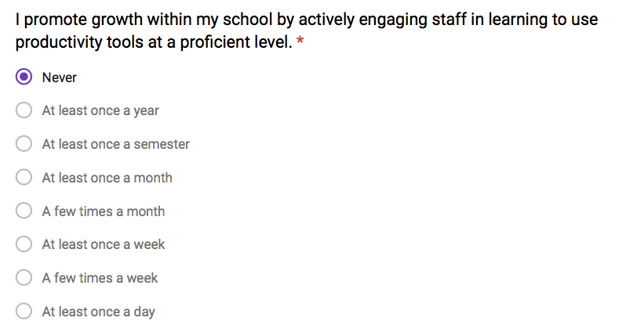
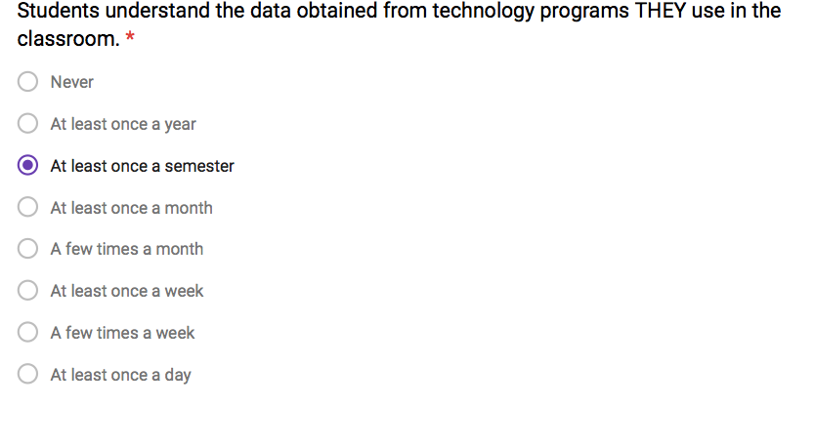
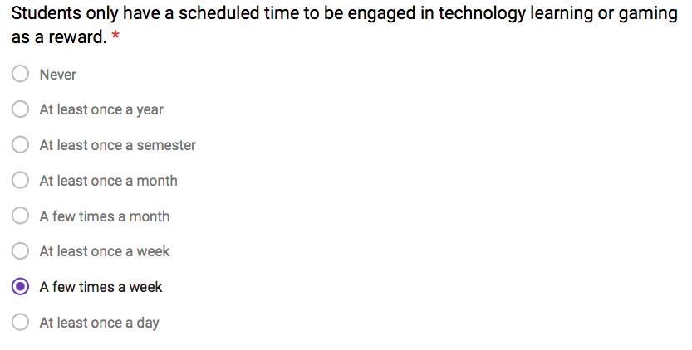
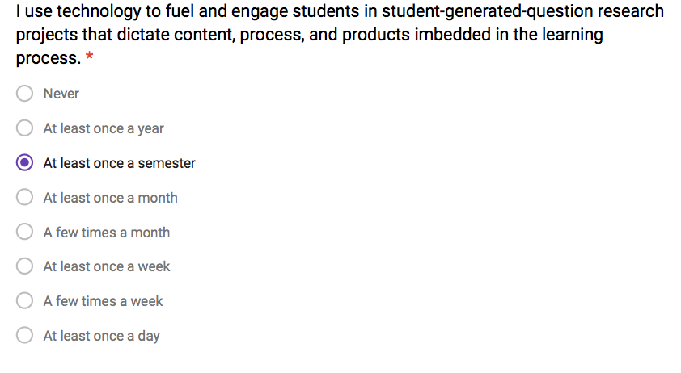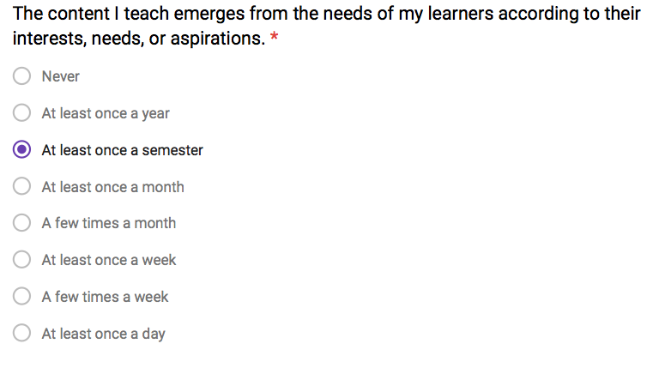

References
B.Beavers, personal communication, October, 2018

